Protocol Image Processing
Disclaimer
I am not a computer scientist and use the following tools primarily as an end-user. The descriptions below are therefore intended as a practical guide rather than a technical explanation of the underlying machine-learning methods. I nevertheless aim to describe the workflow as accurately as possible to facilitate reproducibility.
The workflow for object detection is largely based on the open-source software FlatBug. The original FlatBug repository contains more detailed explanations, advanced implementations, and additional functionality beyond the simplified workflows presented here.
The classifier workflow presented in this protocol is intentionally lightweight and designed for practical use with relatively little coding experience. While the resulting classifier model is comparatively small, training and applying it requires only a few lines of code once the environment and image structure are set up correctly.
Overall, these tools can substantially reduce the manual workload associated with processing large image datasets while still allowing flexible manual quality control and refinement where needed.
Content
Object detection and cropping with FlatBug 1
Purpose 1
Input Images 2
Acquisition 2
Naming 2
Training Data and Fine-Tuning 2
Running FlatBug 3
Option 1: Google Colab 3
Option 2: Local execution 4
Classifier 5
Purpose 5
Training own classifier 5
Preparation on local machine: 5
Setup 5
Apply classifier 6
Manual Sorting 6
Special cases: 6

Object detection and cropping with FlatBug

Purpose
This protocol describes the workflow used to process images of soil mesofauna obtained from BugNet field experiments using a fine-tuned version of the FlatBug object-detection algorithm. The workflow is designed to automatically detect visible organisms in source images and generate cropped images of individual detections for subsequent manual inspection and downstream analyses such as classification, body size measurements, and colour or brightness analyses.
All notebooks, environment files, and model weights required to reproduce the workflow are available in the associated GitHub repository:
https://github.com/CaroleSchoepfer5/BugNet_SoilArthro.git
The repository contains the executable notebooks and supporting files required to reproduce the detection and cropping workflow, while this document serves as a practical user guide describing the setup, processing steps, and quality-control procedures.

Input Images

Acquisition
Consistent image acquisition is important because subsequent analyses (e.g. body size and brightness measurements) depend directly on image quality and scaling. Source images should therefore be standardized with respect to:

- image format
- image resolution
- zoom / magnification
- illumination
- camera settings
- background and imaging setup

Large differences in these parameters may reduce detection performance and can bias downstream analyses of morphological traits such as projected body area or brightness.
The images used in this study were acquired using a Leica [XX] camera system (12 MP, 4:3 aspect ratio). Typical image sizes were approximately 1,000–1,500 KB. Images were collected following the protocol:
- PROTOCOL_Documenting Soil arthropods on BugNet

Naming
Source images should follow a consistent naming convention, as the generated crop names retain information from the original source image. Example:
Input:
- Plot ID_sampling session (ImageNumber).jpg
  - Bruech02A_1 (4).jpg

Output:
- Bruech02A_1 (4)_1.png,
- Bruech02A_1 (4)_2.png,
- …

Training Data and Fine-Tuning
The object detection algorithm used for image processing was the open-source software FlatBug developed by [Svenning et al.]: https://asgersvenning.com/flat-bug
The original FlatBug model is trained on a broad range of datasets and therefore has good general applicability. To improve detection performance for BugNet images, the model was further fine-tuned using manually annotated images from this project. Annotations were created in CVAT (Computer Vision Annotation Tool), where organism silhouettes were manually corrected and refined from predictions generated during an initial FlatBug run rather than being created entirely from scratch. Annotation was performed by me on 423 images containing approximately [XX] individuals, while model training and fine-tuning were carried out by Quentin Geissmann. These BugNet images were subsequently incorporated into the publicly available FlatBug dataset.
During training, the learned parameters of the neural network are adjusted using the annotated examples so that the model learns to recognize and localize objects of interest in new images. The resulting model weights [NAME OF WEIGHTS IN GITHUB] used for image processing in this study were therefore specifically optimized for BugNet images and imaging conditions.
Fine-tuning substantially improved detection performance for the BugNet dataset, although generation of training data and annotation can be time intensive.

Running FlatBug

Option 1: Google Colab
If no local machine with sufficient computational power is available, FlatBug can be executed in Google Colab:
Advantages:
- Free access to GPUs
- No local installation required
Limitations:
- GPU access duration is limited
- Sessions may disconnect unexpectedly and processing progress can be lost if interrupted
- Temporary "credit" limitations may occur
- Requires upload/download through Google Drive
This option is practical for moderate image numbers or batch processing without strict time constraints.

Setup:
- Create a folder on your Google Drive that contains the following three folders:
  - input: upload your batch of images to be processed here
  - model weight: place your model weights here
  - output: this remains empty, the crops will be saved here
- Open BugNet_SoilArthro_FlatBug_colab.ipynb directly in Google Colab
- In the last code block, update the path to your folders (input, output and model weight) and change score_threshold if needed
  - A low score_threshold means that many false positives will be detected but the changes of missing individuals is lower.
- Connect Google Colab to a GPU (top right → Connect → Change runtime type → GPU).
- Run the first code block. You will be asked for permission to access your Google Drive.
- Run the remaining code blocks. The notebook should display:
  - the number of detected input images
  - the selected device (CPU/GPU)
  - a progress bar indicating processing status
- Once processing is complete, download the generated crops from the output folder in Google Drive. Google automatically compresses the files into a .zip archive for download. Extract the downloaded images into your desired folder.
- Perform an initial quality check:
  - Make sure all source images processed
  - Scroll through the generated crops and remove obvious false before continuing with classification.
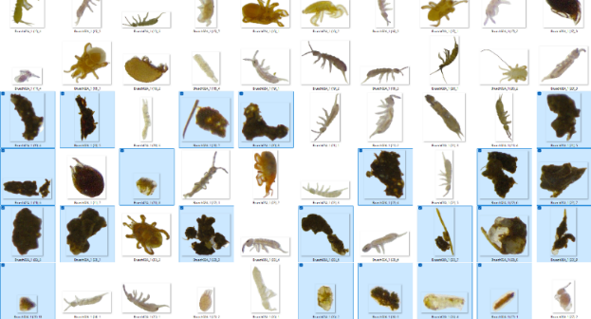

Option 2: Local execution
If a computer with a suitable GPU (Graphics Processing Unit) is available, FlatBug can be run locally.

Setup:
- Install Anaconda
- Open anaconda prompt and load the environment_local_flatbug.yml file
conda create --file environment_local_flatbug.yml
- Launch Jupyter Notebook
jupyter notebook
- Open the file FlatBug_local.ipynb in the jupyter notebook
- On your local machine, create the following folders and update their exact path in the code in FlatBug_local.ipynb (last code block “User settings”):
  - input: upload your batch of images to be processed here
  - model: place your FlatBug model weights here
  - output: this remains empty, the crops will be saved here
- Change score_threshold if needed
  - A low score_threshold means that many false positives will be detected but the changes of missing individuals is lower.
- Run all. The notebook should display:
  - the number of detected input images
  - a progress bar indicating processing status
- Perform an initial quality check:
  - Make sure all source images processed
  - Scroll through the generated crops and remove obvious false before continuing with classification.


Classifier

Purpose
Sort crops (output of Object detection and cropping with FlatBug) into broad taxonomic groups. Assist but not replace human in sorting.

Training own classifier

Preparation on local machine:
Create the following folders:
- Classifier
  - train
    - Class 1 (name your classes as needed)
    - Class 2
    - Class ...
  - val
    - Class 1 (name your classes as needed)
    - Class 2
    - Class ...
- Crops_to_sort
- Crops_sorted
Fill the class folders with manually selected example images of respective class. Split between train and validation (val) ca. 80:20 (or 70:30). Do not use the same image in both folders! Choose as few classes as possible, making them quite broad but still clearly morphologically different from each other. The more example images the better (start with min. 100 images per class).

Setup
- Install Anaconda
- Open anaconda prompt and load the environment_classifier.yml file
conda create --file environment_classifier.yml
- Launch Jupyter Notebook
jupyter notebook
- Open the file SoilArthro_classifier.ipynb in the jupyter notebook and in the first code block adjust the path to the “classifier” folder that contains train/ and val/
- Run the second code block. It should start training your YOLOv8n model (smallest version of real-time object detection and computer vision model developed by Ultralytics)
  - You can adapt the model.train() settings if needed.
  - The training will take some time and resources. Once it is done it will tell you where it saved the model specifics and the validation files and plots. Save the model weights “best.pt” in the classifier folder or another place where you can easily refer to it.

Retraining on tricky images
After each training round and subsequent application of algorithm on new images, I put the misplaced images in the correct class folder in train or val, to improve performance on those apparently tricky images. Then train again with the updated train & val folders and repeat this step until you are satisfied with the accuracy. NOTE: manual control of sorting remains necessary.

Apply classifier
- Install Anaconda
- Open the Anaconda Prompt and create the environment from the supplied environment_classifier.yml file
conda create --file environment_classifier.yml
If the environment is already installed, simply activate it:
conda activate bugcls
- Launch Jupyter Notebook
jupyter notebook
- Open the file SoilArthro_classifier.ipynb
- In the last code block update the paths to:
  - the trained classifier model weigths (best.pt)
  - the source crop folder (crops_to_sort)
  - the destination folder for automatically sorted crops (crops_sorted)
- Run the last code block and check the folders if crops are moved around

The classifier only moves images when the prediction confidence exceeds the user-defined threshold (top_conf). Crops below this threshold remain in the crops_to_sort folder for manual inspection.

Manual Sorting
After automatic classification, manually inspect all folders in crops_sorted and correct misclassified images if necessary. Images remaining in crops_to_sort should also be sorted manually.
Automatic classification substantially reduces manual work but does not fully replace manual quality control.
After checking, move the verified crops into the final storage folder for subsequent analyses.
If many similar classification errors occur repeatedly, retraining the classifier with additional annotated examples may improve performance (see: Retraining on tricky images).

Special cases

Crops containing dirt or partial organisms
Some crops may contain substantial portions of dirt or background material due to imperfect detections or cropping. Minor imperfections are generally acceptable. However, strongly affected crops should be corrected manually using basic image editing software by re-cropping the organism as cleanly as possible. Here two mild examples:
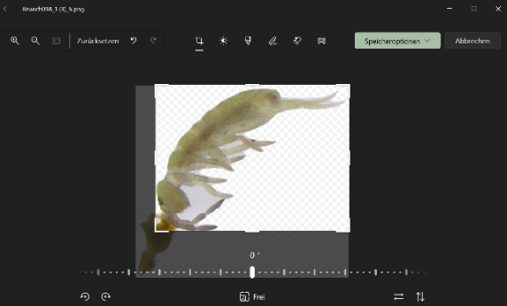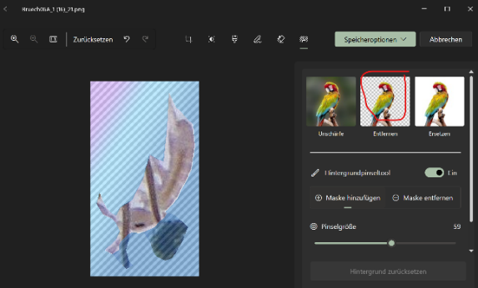

Crops containing multiple individuals
Some crops may contain more than one individual.
In such cases:
- Duplicate the image.
- Assign a new end number to the duplicated image (choose a high number).
- Crop each image so that only one organism remains visible.
Example:

Original crop:
Bruech02A_1 (4)_2.png
Duplicated crop:
Bruech02A_1 (4)_44.png

Ensure that the new filename does not already exist in the dataset. Choose it high enough, there can be many crops stemming from the same source image.

